Sessional No: 09

Problem 1: Prim’s Algorithm
Logical Solution:
In Prim’s Algorithm, the approach to finding the minimum spanning tree (MST) is to first select an arbitrary vertex as the root. Then the minimum weighted edge connecting that vertex is selected and the other vertex which this edge connects is visited. This edge is included in the MST. Then again the minimum weighted edge is searched which is connected to any visited vertex and included in MST. This process is repeated until all the vertices are visited. Finally, the edges inside the MST will make the minimum spanning tree.
Source Code:
#include <bits/stdc++.h>
using namespace std;
// tuple: weight, vertex, vertex
void prim (vector<vector<int>> graph) {
set<int> v;
using edge = tuple<int,int,int>;
priority_queue <edge, vector<edge>, greater<edge>> p;
vector<edge> mst;

v.insert(0); // root
int i = 0;
while (v.size() < graph.size()) {
for (int j = 0; j < graph.size(); j++) {
if (graph[i][j] != 0 && i != j) { // 0 means no edge and i = j means self edge
p.push({graph[i][j],i,j});
graph[i][j] = graph[j][i] = 0;
}
}

label:
int next_vertex = get<2>(p.top());
if (v.count(next_vertex)) {
p.pop();
goto label;
}
mst.push_back(p.top()); p.pop();
v.insert(next_vertex);
i = next_vertex;
}

sort(mst.begin(), mst.end());
cout << endl << "The MST: " << endl << endl;
for (auto i : mst) {
cout << get<1>(i) << " - " << get<2>(i) << ", " << get<0>(i) << endl;
}
}

int main() {
cout << "Number of Vertices: ";
int n; cin >> n;

vector<vector<int>> graph(n);
for (int i = 0; i < n; i++) {
for (int j = 0; j < n; j++) {
graph[i].push_back(0);
}
}

cout << "How many Edges: "; cin >> n;
cout << "Enter the Edges and Weights (Like: 1 2 11): " << endl;
for (int i = 0; i < n; i++) {
int a, b, c; cin >> a >> b >> c;
graph[a][b] = graph[b][a] = c;
}

prim(graph);
}
Input - Output:
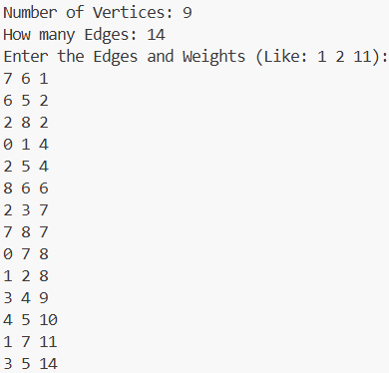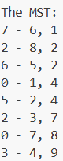
Discussion:
Prim’s Algorithm is an efficient algorithm to find the MST of a graph. Inside the prim() function, the outer while() loop runs E times in the worst case where E is the number of edges. The inner for() loop runs V times where V is the number of vertices and the following pop() function of the priority queue takes O(logE) times as it contains all the edges in the worst case. So the total time complexity of Prim’s Algorithm is O(E)*O(V+logE) = O(EV+ElogE).

Problem 2: Kruskal’s Algorithm
Logical Solution:
In Kruskal’s Algorithm, the approach to finding the MST is to select the minimum weighted edges at a time and make the connected vertices visited. But the edge which forms a cycle with the already selected edges is not considered, This process is repeated until all the vertices are visited. Here, the concept of DSU (Disjoint Set Union) is used to detect cycles. Initially, all the vertices are considered lone trees where they are their own representatives. The two vertices’ representatives are compared to see whether they belong to the same tree when considering an edge. If not, then those trees are merged to make a single tree and the second vertex’s representative is changed to the first one’s. At the end, a single tree will end up and that will be the MST.
Source Code:
#include <bits/stdc++.h>
using namespace std;

vector<int> parent;

int find (int n) {
if (parent[n] == n) return n;
return find(parent[n]);
}

void merge (int n1, int n2) {
int root = parent[n1];
int change = parent[n2];
for (int i = 0; i < parent.size(); i++) {
if (parent[i] == change) parent[i] = root;
}
}

void kruskal (vector<vector<int>> graph) {

for (int i = 0; i < graph.size(); i++) { // every node's parent is itself
parent.push_back(i);
}

using edge = tuple<int,int,int>;
vector <edge> e; // all edges
vector <edge> mst; // safe edges

for (int i = 0; i < graph.size(); i++) { // every edge now in e
for (int j = i; j < graph.size(); j++) {
if (graph[i][j] != 0 && i != j) { // 0 means no edge and i = j means self edge
e.push_back({graph[i][j],i,j});
}
}
}

sort(e.begin(), e.end()); // sorted according to weight in increasing order

set<int> v;
edge i = e[0];
while (v.size() < graph.size()) {
int n1, n2;
n1 = get<1>(i);
n2 = get<2>(i);
if (find(n1) != find(n2)) {
mst.push_back(i);
merge(n1,n2);
}
v.insert(n1);
v.insert(n2);
e.erase(e.begin());
i = e[0];
}

sort(mst.begin(), mst.end());
cout << endl << "The MST: " << endl;
for (auto i : mst) {
cout << get<1>(i) << " - " << get<2>(i) << ", " << get<0>(i) << endl;
}
}

int main() {
cout << "Number of Vertices: ";
int n; cin >> n;

vector<vector<int>> graph(n);
for (int i = 0; i < n; i++) {
for (int j = 0; j < n; j++) {
graph[i].push_back(0);
}
}

cout << "How many Edges: "; cin >> n;
cout << "Enter the Edges and Weights (Like: 1 2 11): " << endl;
for (int i = 0; i < n; i++) {
int a, b, c; cin >> a >> b >> c;
graph[a][b] = graph[b][a] = c;
}

kruskal(graph);
}
Input - Output:
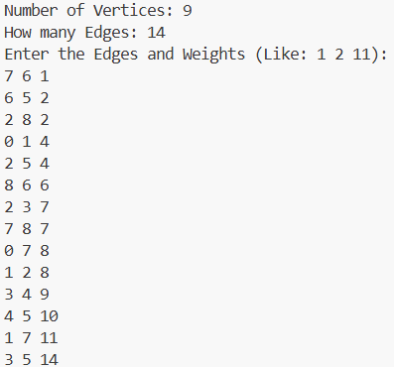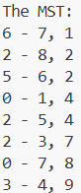
Discussion:
Kruskal’s Algorithm is another efficient algorithm to find the MST of a graph. Inside the kruskal() function, the for() loop runs for V times to set the parents (representatives) of vertices to themselves where V is the number of vertices. Sorting the edges takes O(ElogE) time where E is the number of edges. The while() loop will run for E times in the worst case. find() takes O(1) time and merge() takes O(V) time in the worst case. So, the total time complexity is O(V)+O(ElogE)+O(E)*O(V) = O(EV+ElogE), which is the same as found for Prim’s Algorithm.

